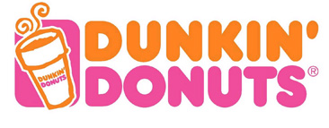
BBI2O
Fabulous Franchise Fair Assignment
Presentations

Due Dates: First Week of October

 | Student | Franchise | Date
1 | Rahul | Expedia
2 | Tony | Pizza Pizza
3 | Kevin W | Mr. Lube
4 | Kevin K | Tim Hortons
5 | Eeshaan | Booster Juice
6 | Ethan Mor | UPS
7 | Rena | KFC
8 | Wilton | McDonald’s
9 | Yam | Pita Pit Rexall
10 | Fredric | 2nd Cup Manchu Wok
11 | Ivan | A & W
12 | Ethan Mck | New York Fries
13 | Shubham | Dominos Shoppers Drug Mart
14 | Emin | Taco Bell Swiss Chalet
15 | Darja | Pet Value
16 | Mustafa | Subway
17 | Simon | Wendy’s
18 | Oz | Kumon
19 | Shruti | iHop
20 | Johnson | 7/11 Kento Sushsi
21 | Holly | Dairy Queen Sleep Country
22 | Petar | Country Style Coffee  Jimmy Johns, Dunkin Donuts
23 | Brandon | Harvey’s All Star Wing’s & Ribs
24 | Shon | Big Smoke Burger  Mr. Sub, Red Lobster
25 | Andre | Burger King
26 | Isaac | Popeyes
27 | Michael | Boston Pizza
28 | Chris | Pizza Hut

