SNC 1D Electricity Unit - Review Name: ______________________

GENERAL STUDY TIPS:
- Before you start to study, make sure your notebook is complete and your notes are in order.
- Make condensed study notes by listing the main points from each topic, with an example. You may use the following summary of the unit to help you.
- Make sure to review all lessons, worksheets, homework, and quizzes.

Please bring the following to the test: (there will be NO sharing)
Pencil
Eraser
Ruler
Calculator

13.1 – Circuit & Circuit Diagrams
- What are the 4 basic parts of a circuit? Provide descriptions and examples for each.
- Explain the difference between opened and closed circuits. Draw examples of each.
- Memorize the main symbols for drawing circuit diagrams. What are the rules to follow when drawing circuit diagrams?
- Be able to draw circuits, using the correct symbols, if given a word description of it. Indicate the flow of electrons in the circuit.

13.3 – Electric Current
- Define current and provide the symbol for it and SI unit used to measure it. What device is used to measure it? How is the device that measures it connected in a circuit?
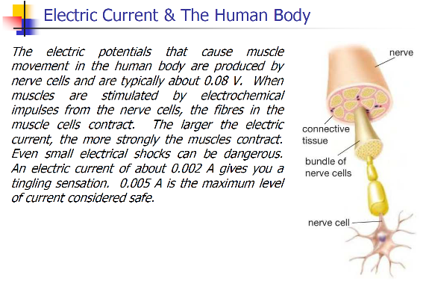
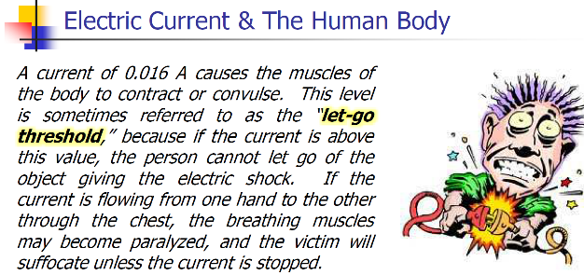
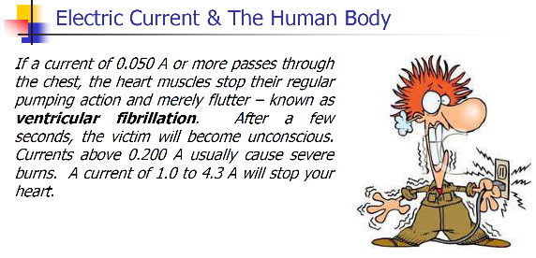
- Read the description below and pg.557 to understand the Human Body and Electrical Shock

13.5 – Potential Difference
- Define potential difference and provide the symbol for it and SI unit used to measure it. What else is it called? What device is used to measure it? How is the device that measures it connected in a circuit?
- What is potential energy? Use this to help explain how a battery works. (Section 12.3 – Electric Cells) or understand the battery video shown in class

13.7 – Resistance in Circuits & 13.9 – Relating Current, Voltage, and Resistance
- Define resistance and provide the symbol and SI unit used to measure it. What is Ohm’s law? What is the formula used to calculate V? Be able to manipulate the equation to calculate for I or R (use GRASS)
- What are the 4 factors that affect resistance? Describe what a resistor is and what a short circuit is.

13.10 – How Series and Parallel Circuits Differ
- Understand the general rules for electric potential of loads in series and parallel circuits, and current in series and parallel circuits. If given a circuit, be able to fill in electric potential (V) readings for cells/batteries and loads. Be able to fill in current (I) readings anywhere along the circuit. Be able to calculate resistance at various points in the circuit.
- Make sure to go review the worksheet on Ohm’s Law in Series & Parallel Circuits.

12.4 – Forms of Current Electricity
- What’s the difference between static and current electricity?
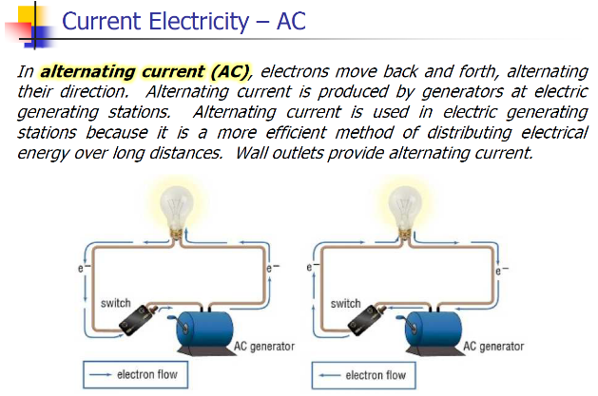
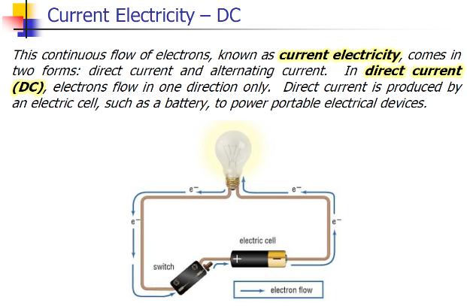
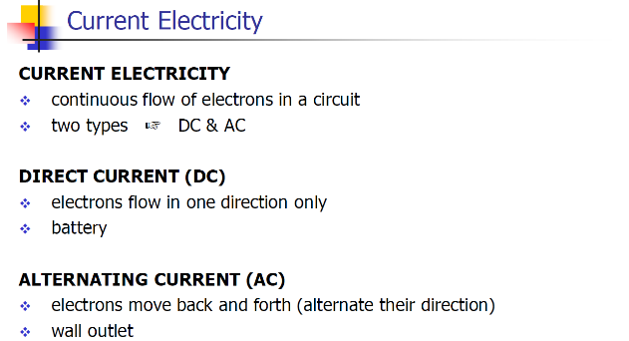
- What is the difference between Alternating Current (AC) and Direct Current (DC)? See below.

12.5 – Generating Current Electricity
- What are the different types of ways of generating electricity (hydroelectric, thermal, nuclear, tidal, biomass, geothermal, wind, and solar), and a brief explanation on how they work. Which one is renewable and non-renewable.
- What are the advantages and disadvantages of the above mentioned methods of generating electricity.

12.7 – Electrical Power and Efficiency
- Define electrical energy and electrical power and know the symbols used to represent them, as well as the SI units they are measured in.
- Be able to calculate energy using the equation E = P x t and E = V x Q. Be able to manipulate these equations to solve other variables. Use proper format when solving problems (GRASS).
- What are the units of energy your electric meter measures in? How would you calculate it mathematically?
- What is wattage? How do you calculate it?
- Be able to calculate the cost of energy, if given the cost per kWh.

Review
- Worksheet on Ohm’s Law in Series and Parallel Circuit
- Mixed Electricity Practice Problems
- Practice Quiz

The formulas will be given on your test (no need to memorize). Familiarize yourself with the formula sheet given to you.

