BBI20-INTRODUCTION TO BUSINESS
STRAND 1 BUSINESS FUNDAMENTALS

LEVELS OF MANAGEMENT – LARGE COMPANIES

There are four functions for management - planning, organizing, directing, and controlling. The functions vary by the level in the management hierarchy.

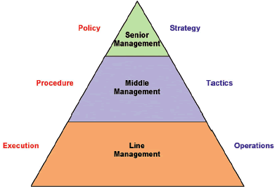

The term supervisor could be applied at all management levels of the organization to those who direct the work of others. In common usage, however, the title tends to be used only in the first level of the management hierarchy. If an organization were divided into top, middle, and lower managerial levels, the term generally applies to the lower level.

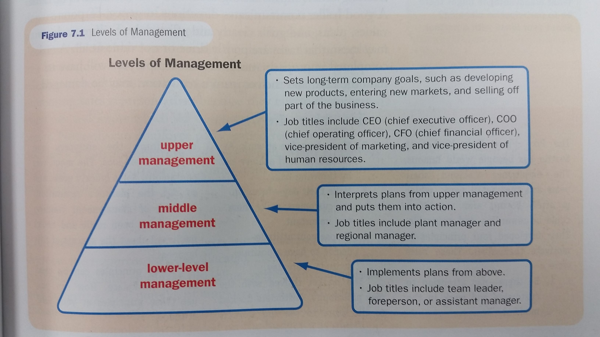

QUESTIONS (Do some research or ask a “business” person/family member if required)

1. In general, which level(s) of management would form the “executives” of an organization?

2. Where do the “board of directors/directors of the organization” and the shareholders fit on the pyramids? (They are not part of management).

3. Fill in each textbox below with the following terms. Research the meaning of each term if required.

VP Production; Chairman & The Board of Directors; President; COO, VP Human Resources; CFO; CEO; VP Finance; VP Marketing; CMO

SHARE HOLDERS

