Conductors and Insulators

Conductors and Insulators

A. Complete the following Venn diagram.

Materials that conduct electricity well:

Conclusion:
Materials that do not conduct electricity:

Conclusion:

Con

Materials that conduct some electricity:

Conclusion:

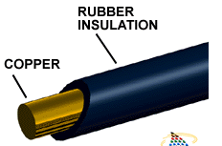
C. Electrical wire is the medium through which electricity is carried to and through each individual home that uses electrical power. It is made of copper (metal) that is covered by a plastic/rubber.
(i) Identify the conducting and insulating material.

(ii) Why must the wires be covered with a plastic? Explain in relation to the flow of electrons.

D. Why do you feel more static shocks in the winter?

Conductor & Insulator Venn diagram - Answers
Materials that do not conduct electricity (insulators):
- Rubber
- Glass
- Plastic
- Paper
- Pencil

Conclusion: Most non-metals are insulators

Con

Materials that conduct electricity well:
- Copper
- Tin
- Salt solution

Conclusion: Most metals are good conductors
Materials that conduct some electricity:
- Iron
- Water
- Sugar solution

Conclusion: Some materials are harder to predict

