Economic Basics

What is a business?
- A for-profit business ________________________________________
to satisfy the needs, wants, and demands of consumers for the purpose of a making profit.
- A non-profit and/or not-for-profit organization _____________________
_________________________________________________.

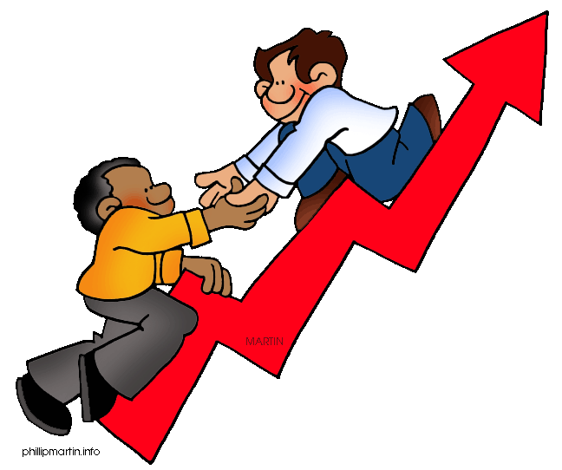
For-profit Business
- By supplying goods and services, a business can make a profit.
  - ______________ is the income left after all costs and expenses are paid.
  - ______________are the payments involved in running a business and the assets that get “used up” operating it.
  - ______________is the money required to produce or provide the goods and services.
  - ____________________________________________

When a business makes a profit, it can
- ____________________________________________________
- ____________________________________________________
- ____________________________________________________
- The business is considered _________________ when debts are paid and financial obligations are met.

Non-profit Organizations and Not-for-profit Organizations
- The primary motive of a ___________________________ is to raise funds for a specific goal. Only charities and charitable organizations are called non-profit and are allowed to raise such funds.

- A _______________________________ uses any surplus funds to improve the services offered to its members. However, they do not distribute profits to members.

- A _______________________________, unlike a not-for-profit organization, consists of an independent association of persons who join together to meet economic, social, and cultural needs and goals.

Large or Small
A small or medium-sized business (SMB) can be classified by the following characteristics:
  - ____________________________________________________
  - ____________________________________________________
  - ____________________________________________________

Forms of business ownership:
- ________________________________________________
- ________________________________________________
- ________________________________________________
- ________________________________________________
- ________________________________________________
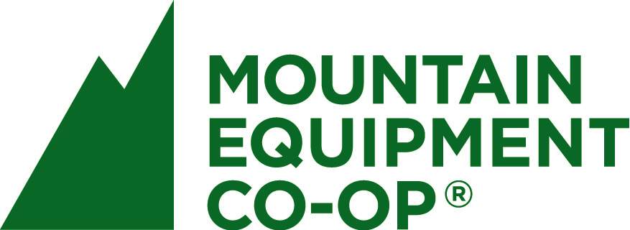

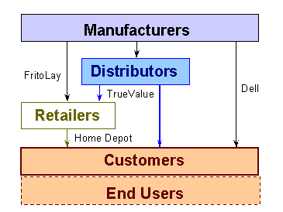
Channels of Distribution
- A business can be classified according to how it _______________ goods or services to the customer.

Role of the Consumer
- ___________________ are the businesses that make goods or provide services that consumers need or want.
- ___________________ are the people who purchase goods and services from producers.
- A __________________ or location is where producers and consumers come together to buy and sell their goods and services.

Characteristics of Entrepreneurs
- ____________________ are individuals who are risk-takers and problem-solvers. They are acutely aware of opportunities in the marketplace and take advantage of these in their businesses.
- Important entrepreneurial characteristics include:
  - ________________________________________________
  - ________________________________________________
  - ________________________________________________
  - ________________________________________________

Consumer Needs and Wants
- Entrepreneurs often start businesses to satisfy consumer ______________. Basic survival needs for individuals are ____________________________. _________________________. However, entrepreneurs can also provide consumers with new products or services that are not considered a need but a _______________— something that adds comfort or pleasure to their lives.
Examples of wants include ______________________________________.

Attracting Consumer Interest
- __________________________________________________________
- __________________________________________________________
- __________________________________________________________

Economic resources
- Economic resources also known as _____________________________, are the means through which goods and services are made available to consumers.

NATURAL  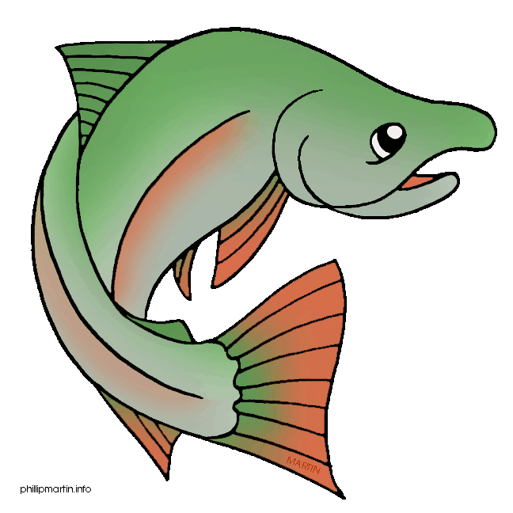  RESOURCES | HUMAN  RESOURCES  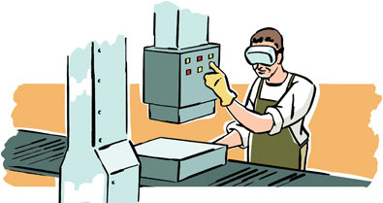 | CAPITAL  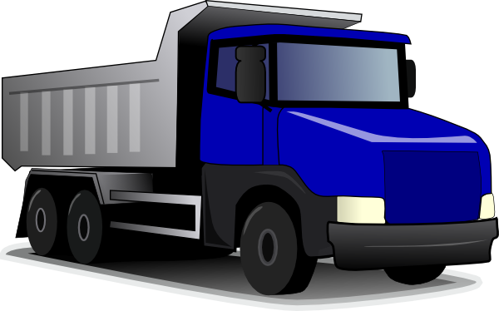  RESOURCES
Definition: | Definition: | Definition:
Examples: | Examples: | Examples:

- _________________________ are a way of dealing with the selection, production, distribution, and consumption of goods and services. Government and business work together to foster activity and growth in the marketplace.
Demand, Supply and Price
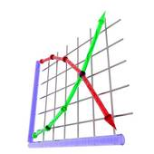
- __________________ is the quantity of a good or service that ________________ are willing and able to buy at a particular price.
- _________________ is the quantity of a good or service that _________________are willing and able to provide within a range of prices that people would be willing to pay.
- When prices _______________ consumers buy more and demand goes ________.
- When prices _______________ consumers buy less and demand goes __________.
- Conditions that create demand are:
  - _____________________________________________
  - _____________________________________________
  - _____________________________________________
  - _____________________________________________

